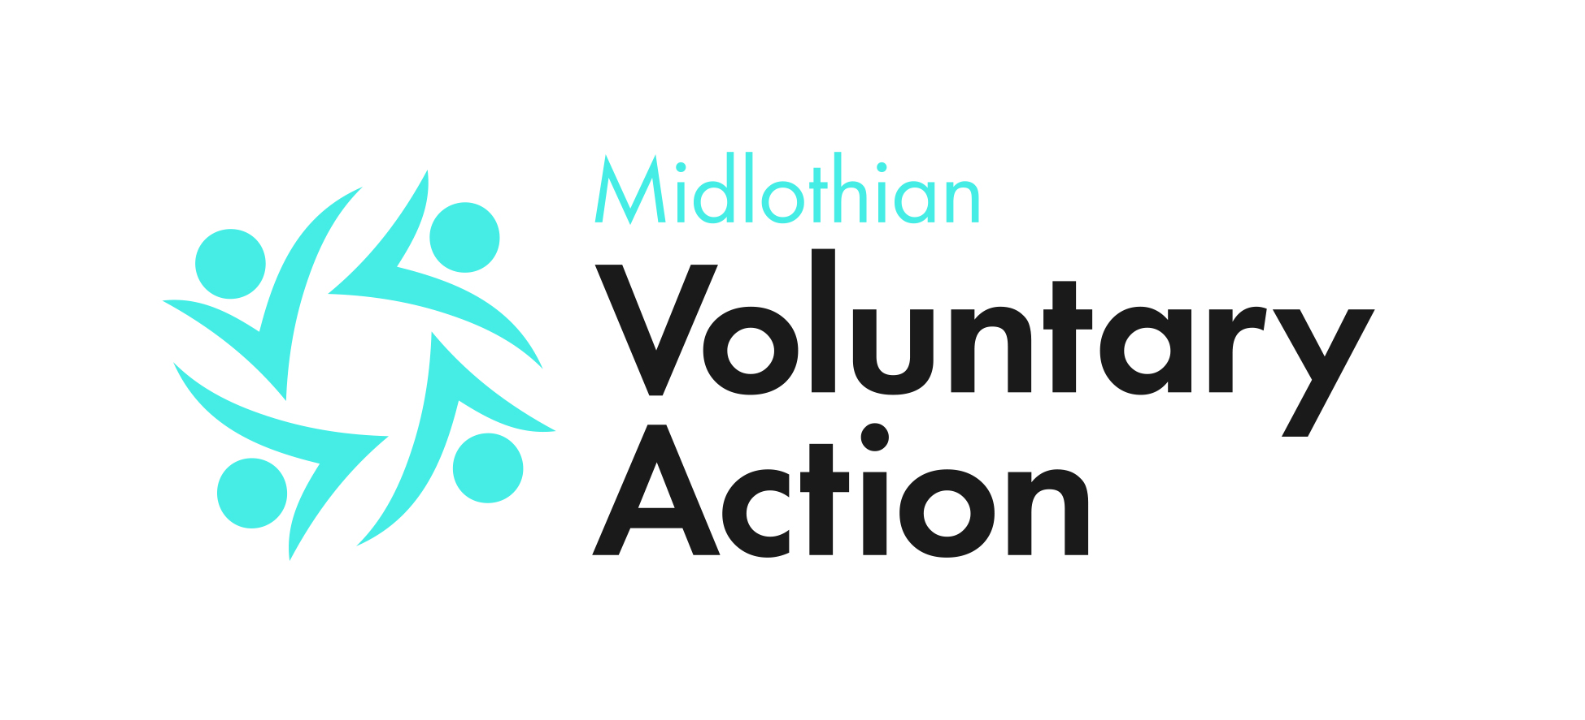

Annual General Meeting
of
Midlothian Voluntary Action

Tuesday 16 March, 2021, 5pm

Online

Agenda

- Opening Remarks

- Apologies for Absence

- Minutes of AGM 2019

- To receive the Annual Report

- To receive the Treasurer’s Report

- Election Board Members

  - Board of Directors

  - Correspondence

- Proposal to use J. Anderson auditors for 2020/21

- Special Resolution: That the existing articles of association in their entirety be removed and substituted by the new articles of association included with this agenda.

Close of General Meeting

