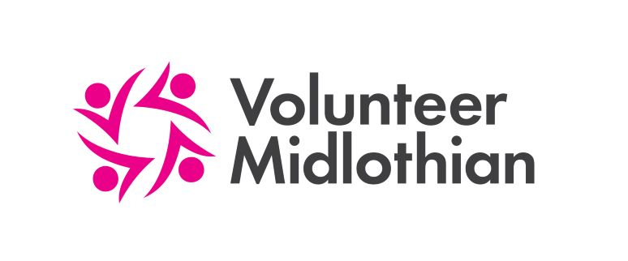

Extraordinary General Meeting
of
Volunteer Midlothian

Online

Tuesday 16 March 5pm, Online

Agenda

- Opening Remarks

- Special Resolution: That the existing articles of association in their entirety be removed and substituted by the new articles of association included with this agenda.

Presentation: TSI activities and achievements

