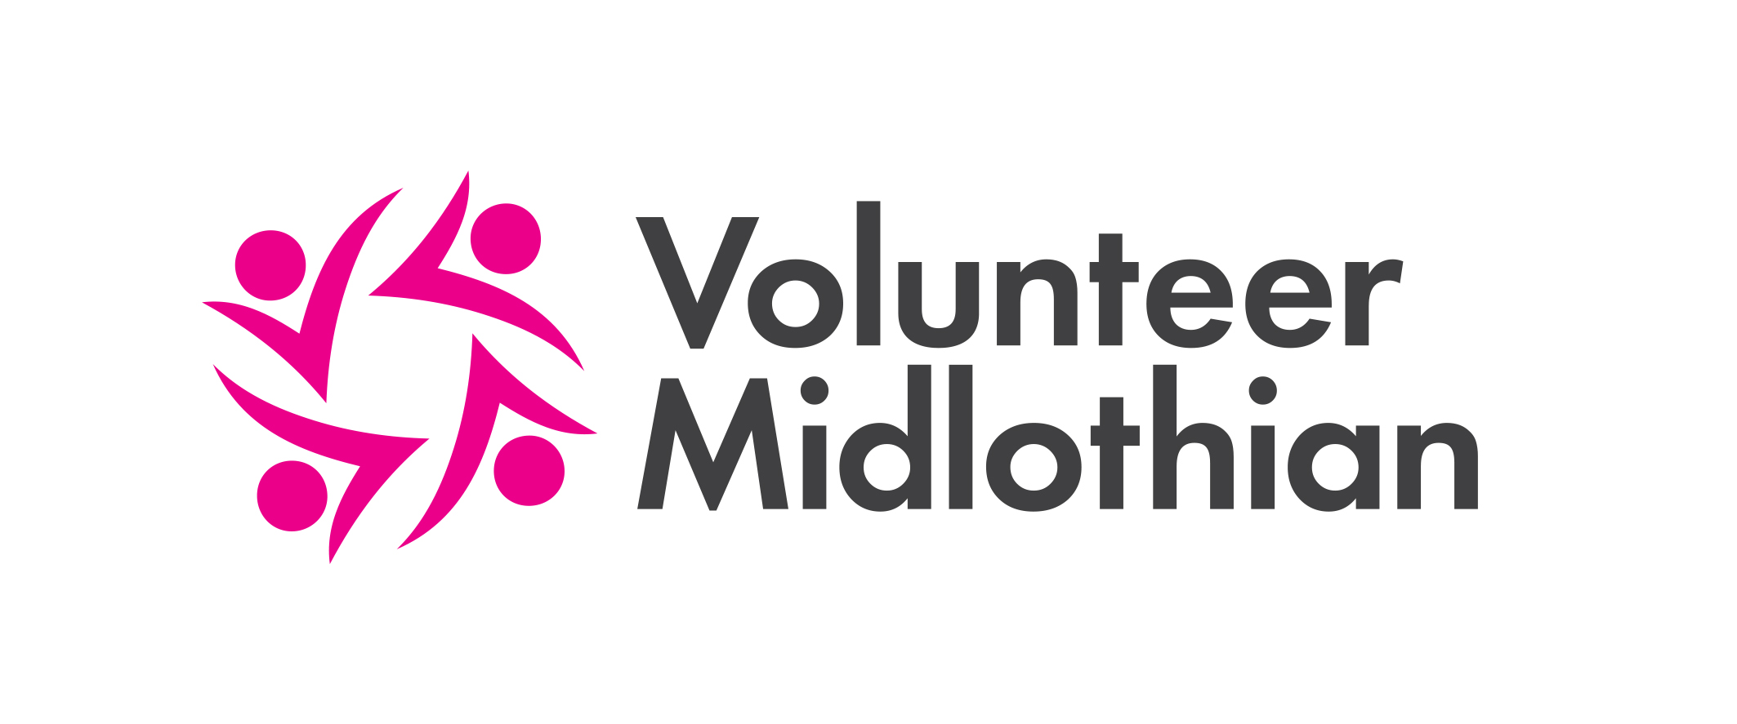
Organisation Registration Form

Please complete this form to register your organisation with Volunteer
Midlothian. You will then be able to register your volunteering opportunities with us.

Questions marked with a * are mandatory.
Main Contact
*1 Please provide details of the person who would be your preferred first point of contact for Volunteer Midlothian. Please indicate if you do not wish us to pass these details on to prospective volunteers – e.g. if this is a home address.
Title: Email:
*First name: Tel no:
*Last name: Mobile no:
Job title/Position: Preferred contact method: Phone Email Post
Can this person’s details be shared with other voluntary or statutory organisations? Yes No
Can this person’s details be published on the web as the main contact for this organisation? Yes No
Would you like to receive our monthly e-bulletin? Yes No
2 Other Contacts - please give details of any other people you feel it would be appropriate for us to record. Tick Receive Bulletin if this contact would like to receive regular email information bulletins from us.
Name: Position:
E-mail: Receive e-mail bulletin? Telephone No:
Name: Position:
E-mail: Receive e-mail bulletin? Telephone No:

Organisation Details
*3 Organisation Name:
*4 What type of organisation are you? Select one only.
Voluntary Organisation/Community Group
Private
Statutory
Educational Establishment
Partnership/Network/Forum
Other

Primary Location
*5 Full address details of organisation: Phone number:
*Address Line 1: Email:
Address Line 2: Website:
*Town/City: Twitter:
*Postcode: Facebook:
*6 Is this a home address? Yes No

*7 Is your organisation a registered charity? Yes No If yes, what is the charity number?

*8 Are you a branch (or project) of a larger organisation? Yes No If yes, which larger organisation?

*9 What is the legal status of your organisation? Please select only one which best describes your organisation.
Unincorporated association
Company Ltd by guarantee. Please give number (if applicable)
Scottish Charitable Incorporated Organisation (SCIO)
Community Interest Company (CIC)
Industrial & Provident Society
Trust
Not applicable
10 What year was your organisation (or branch/project) established?

11 What are your organisation’s main areas of activity? Please select up to 3.
Addictions Helplines
Advice/Information Heritage
Advocacy Horticulture
Agriculture Housing/Homelessness
Animal Welfare Housing Association
Arts and Culture Law and Justice
Befriending/Mentoring Learning Disability
Black/Minority Ethnic Marketing
Campaigning/Lobbying Media
Carers Men
Charity Shop Mental Health
Children Services Money/Debt Advice
Community Council Offenders/Ex-Offenders
Community Development Older People
Community Event Overseas Aid/Developing World
Community Facilities Physical Disability
Community Forum Poverty
Community Safety Refugees/Asylum Seekers
Community Transport Residents Association
Counselling Self-Directed Support
Credit Unions/Community Banking Self Help/Support
Drug/Alcohol Issues Sensory Impairment
Education/Learning/Training Sexuality
Emergency Response/Disaster Relief Single Parent
Employment Social Care
Environment/Recycling Social Economy/Social Enterprise
Equality Sport/Leisure/Recreation
Faith/Religion/Belief Volunteering
Family Support Welfare Rights/Benefits
Food Banks Women
Fundraising/Funding Young People
Health

*12 In which geographical areas do you operate?
Specific Local Neighbourhoods (e.g. Gorebridge – see below)
Local Authority Wide (e.g. whole of Midlothian)
More than one local authority
Scotland wide
UK wide
International

If specific local neighbourhoods, which ones do you serve? Please select as many as applicable.
Bilston and Roslin
Bonnyrigg and Lasswade
Dalkeith and Woodburn
Damhead & District
Danderhall & District
Eskbank and Newbattle
Gorebridge
Howgate
Loanhead & District
Mayfield and Easthouses
Moorfoot (Borthwick, Carrington, North Middleton & Temple)
Newtongrange
Penicuik & District
Poltonhall & District
Rosewell
Tynewater (Crichton, Dewarton, Edgehead, Fala, Ford, Oxenfoord, Pathhead & Tynewater)
13 Please provide a brief statement about your organisation’s main aims and objectives (e.g. a mission statement), as you would like others to read about you. This should be no longer than 150 words.

14 What are your opening times/available hours (if applicable)?
Monday | Tuesday | Wednesday | Thursday | Friday | Saturday | Sunday

15 Does your Primary Location have:
Accessible Premises Yes No Partial
Accessible Parking Yes No Partial
Accessible Toilets Yes No Partial
Any other access issues?
If you have any additional premises, please request an Additional Location Sheet and complete one for each additional location.

Volunteering
*16 Do you engage volunteers? Yes No
17 How many volunteers does your organisation currently engage (excluding board/committee members)?
18 How many volunteers are on your board/committee?
19 What is the average number of hours per month contributed by a single volunteer?
20 Are volunteers in your organisation covered by the following?
Yes No
Equal Opportunities Policy
Health & Safety Policy
Volunteer Policy
Child Protection Policy
Vulnerable Adults Policy
Equality and Diversity Policy

21 Volunteers aged 12-25 are eligible to claim certification for their volunteering through the national Saltire Awards Scheme. This is a great way to attract volunteers and all you need to do is verify information provided by your young volunteers of the dates and number of hours that they have volunteered. You may however wish to opt out of this scheme if, for example, your opportunity is not suitable for volunteers under 25. Please tick this box if you do NOT want your organisation to be part of the Saltire Awards.

22 Please tick if your organisation is registered with Volunteer Scotland to access PVG Membership Scheme Checks
23 How did you hear about Volunteer Midlothian?
24 Does your insurance cover volunteers?
Yes No
25 Is your organisation a member of Volunteer Midlothian? Information about the benefits of membership can be found on the Membership page of our website www.volunteermidlothian.org.uk .
Yes No

Declaration
Volunteer Midlothian does not screen or provide insurance for any volunteers it refers to your organisation. This is the responsibility of the individual organisation. The information provided by you in this form will be entered on to Milo, an ICT platform for Third Sector Interfaces (TSIs) across Scotland. The information you provide will be used to help signpost prospective volunteers to your organisation and to allow us to provide suitable support for your organisation.
Any personal information you give us (e.g. the name, personal email or home address of a main contact) will be held and used in accordance with the Data Protection Act 1998. Personal information held on Milo will not be disclosed to any unauthorised person or body without your permission.
Only authorised Milo users will have access to all of the information you supply. In the case of specific interactions with staff or volunteers, details will not be shared out with the local TSI (Midlothian).
General organisational information will be made available to other organisations and the public through approved local and national websites (such as www.volunteerscotland.org.uk, www.volunteermidlothian.org.uk). We will not display personal contact names or information unless you give us permission to do so.
Anonymised statistical data gathered from our database may be used to report to our various funders.
Please keep a copy of this form for your records.
I can confirm that I have read the information above and I confirm that the details I have given are correct
I confirm that I represent a not for profit organisation
I am authorised to complete this form on behalf of my organisation
Name (please print): Position in Organisation:
Signature: Date:

Thank you for completing this form. Please return to us either by email or post to the address below.

Volunteer Midlothian, 4-6 White Hart Street, Dalkeith EH22 1AE
t: 0131 663 9471 mobile 07859 914587
info@volunteermidlothian.org.uk w: https://www.thirdsectormidlothian.org.uk/vm/

