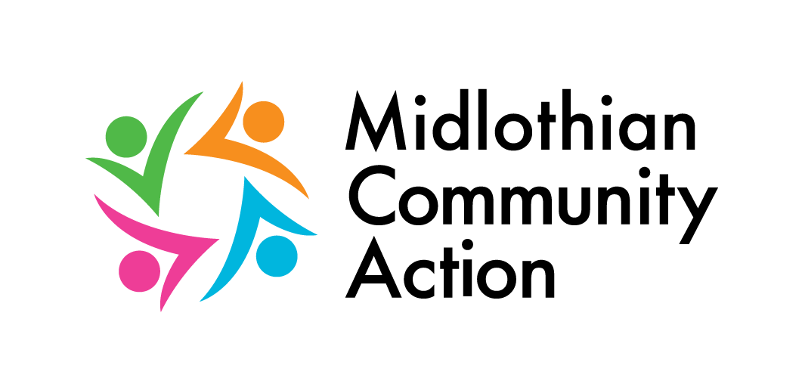
Volunteer Opportunity Registration Form

Fill in a separate form for each different opportunity
Please answer all questions.
1. Title of Opportunity:
2. Name of Organisation:
3. Contact Name in Organisation:
Position:
Tel. no:
Email:
If you work from home and would rather your contact details were not published on the web / directories you can choose to display Midlothian Community Action details with the opportunity.
I would like to use Midlothian Community Action’s details

4. Where does this opportunity happen (please supply an appropriate postcode as potential volunteers will search our website by postcode)?

5. What are the travel details e.g. is it on a bus/train route (no more than 35 words)?

6. When does the volunteer opportunity start? (dd/mm/yy):
Is there an end date? If yes please enter (dd/mm/yy): or is it ongoing (tick if YES):

7. Full description of the opportunity (no more than 150 words).

8. Which one of the following activities best matches the volunteer opportunity?
Administration/Office work Advice/Information giving Advocacy/Human Rights
Arts (Music/drama/crafts) Befriending/Mentoring Campaign/Lobbying
Care/Support worker Catering Charity Shops/Retail
Committee Work Community/Economic Dev. Work Computing
Conservation/Gardening Counselling Disaster/Emergency relief
Driving/Escorting Equal Opps/Race Relations Finance/Accountancy
Fundraising Home-based Volunteering Justice/Legal assistance
Languages/Translating Library/Information Management Management/Business Skills
Marketing/PR/Media Online volunteering Playschemes/Children’s Clubs
Practical/DIY Research/Policy work Residential Volunteering
Short term/Seasonal Specialist/Technical Sports, outdoor activities
Tutoring/Supporting Learners Volunteering for under 16s Youth work

9. Which one of the following Client Groups best matches the volunteer opportunity?
Animals Anti-poverty work Arts (music/drama/crafts)
Carers Children Crime/Safety
Disaster/Emergencies Drugs/Alcohol issues Education/Literacy
Elderly Environment Ethnic minorities
Families Gender/Sexuality General Public
Health/Hospitals/Hospices Homeless/Housing Human/Civil rights/Justice
Learning disabilities Leaving/in care LGBT
Literacy needs Local Authority Local Community
Lone Parents Low Income Households Mental Health
Men’s Groups Miscellaneous Museums/Galleries/Heritage
New Beneficiary/Client Group Offenders/Ex-offenders Older People
Overseas aid/Developing world Parents People with ill health
Physical disability Refugees/Asylum seekers Religion/Faith
Residents of Disadvantaged Neighbourhoods Sensory impairment
Sport/Outdoor activities Tackling Unemployment Unemployed
Victims of Crime Volunteers Women’s Groups
Young people

10. Are there any restrictions on who can be a volunteer?
Minimum Age: Maximum Age: Please explain any age restrictions:
Are there any other restrictions?

11. What skills, attitudes, experience does a person need to do this volunteer opportunity (max 35 words)?

12. Number of volunteers required for this opportunity:

13. What are the minimum hours per day, week etc that a volunteer would need to do for this opportunity e.g. 4 hours per week, 2 hours per fortnight, etc:
Hours per [ day] [ week] [ fortnight] [ month] [ quarter]
Other (please describe):

14. Is there a minimum commitment expected of the volunteer e.g. 6 weeks, 3 months etc.
(Enter a number) [ Days] [ Weeks] [ Months] [ Years
Other (please describe):

15. Please tick when the opportunity happens. Tick as many boxes as appropriate.
Morning Afternoon Evening  Monday  Tuesday  Wednesday  Thursday  Friday  Saturday  Sunday | Does the opportunity take place in school holidays?  Yes No  Does the opportunity take place in term-time?  Yes No

16. Are volunteers covered by appropriate insurance?
(Note: it is a requirement of Midlothian Community Action that organisations who advertise their opportunities through us have appropriate insurance which covers volunteers).
Yes No, but would like more information

17. Training and Support for Volunteers
Yes No
Will the volunteer be offered induction/start up training?
Will the volunteer be offered on-going training?
Will the volunteer be offered support?

18. Please give a brief description of induction, ongoing training and support for the volunteer (max 35 words):

*19. Will the volunteer have a named contact person at your organisation? Yes No
(Note: it is a requirement of Midlothian Community Action that organisations who advertise their opportunities through us have a named contact person who provides support to their volunteers).

20. Is childcare/ are childcare costs available for volunteers? Yes No

21. Is there disabled access and accessible toilets
where the opportunity happens? Yes No

22. Are expenses available for volunteers? Yes No
If yes, please give details on what, how and when expenses are paid e.g. we pay public transport rates and reimburse volunteers every week. Also include mileage rates if applicable. (max 35 words)

23. What selection method(s) will be used for prospective volunteers for this opportunity?
Application Form Induction/training Informal chat
Interview PVG Membership Required References
Trial Period Other(s):

Midlothian Community Action does not screen or provide insurance for any volunteers it refers to your organisation. This is the responsibility of the individual organisation. The information provided by you in this form will be entered on to our database and used to help signpost prospective volunteers to your organisation. It will be used in accordance with the principles of the Data Protection Act 1998.
I can confirm that I have read the information above and I confirm that the details I have given are correct
I am authorised to complete this form on behalf of my organisation
Name: Position in Organisation:
Signature: Date:

Thank you for completing this form. Please return to us either by email or post to the address below.

Midlothian Community Action, 4-8 White Hart Street, Dalkeith EH22 1AE
t: 0131 663 9471 mobile 07859 914587
volunteerning@mca.scot w: www.mca.scot

